SEC Form 4

FORM 4

Check this box if no longer subject to Section 16. Form 4 or Form 5 obligations may continue. See Instruction 1(b).

Check this box to indicate that a transaction was made pursuant to a contract, instruction or written plan for the purchase or sale of equity securities of the issuer that is intended to satisfy the affirmative defense conditions of Rule 10b5-1(c). See Instruction 10.

UNITED STATES SECURITIES AND EXCHANGE COMMISSION
Washington, D.C. 20549
Washington, D.C. 20549 |  | OMB APPROVAL
STATEMENT OF CHANGES IN BENEFICIAL OWNERSHIP
STATEMENT OF CHANGES IN BENEFICIAL OWNERSHIP |  | OMB Number: | 3235-0287
STATEMENT OF CHANGES IN BENEFICIAL OWNERSHIP |  | Estimated average burden
Filed pursuant to Section 16(a) of the Securities Exchange Act of 1934 |  | hours per response: | 0.5
or Section 30(h) of the Investment Company Act of 1940
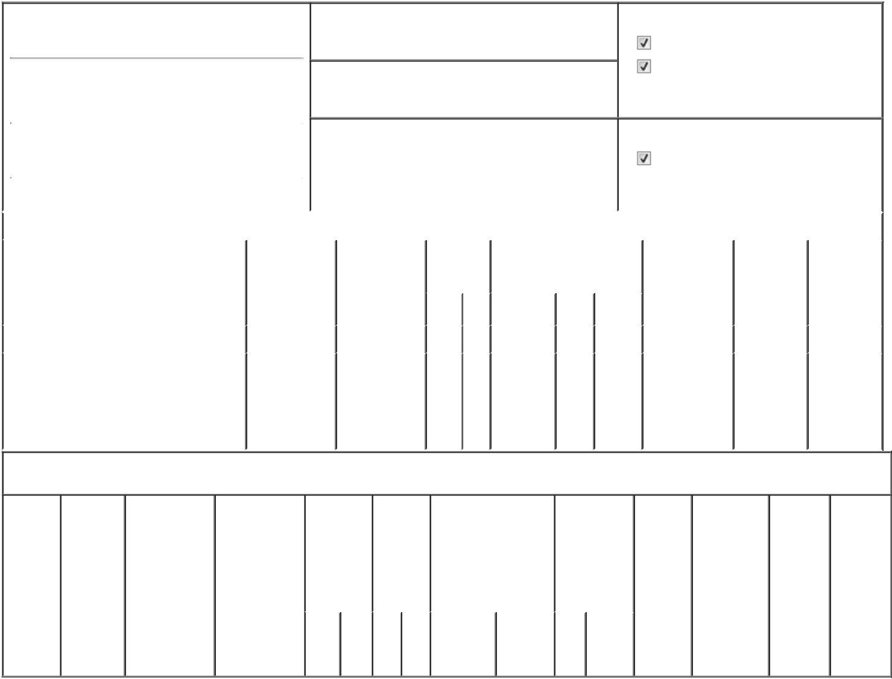

1. Name and Address of Reporting Person*
Guzzi Anthony

(Last) (First) (Middle)

301 MERRITT SEVEN

2. Issuer Name and Ticker or Trading Symbol

EMCOR Group, Inc. [ EME ]

3. Date of Earliest Transaction (Month/Day/Year)

01/02/2026

- Relationship of Reporting Person(s) to Issuer (Check all applicable)

Director 10% Owner

Officer (give title Other (specify

below) below)

Chairman, President and CEO

 |  |  |  |  | 4. If Amendment, Date of Original Filed (Month/Day/Year) |  |  |  |  | 6. Individual or Joint/Group Filing (Check Applicable
 | (Street)
 |  |  |  |  |  |  |  |  |  | Line)
 |  | NORWALK | CT | 06851 |  |  |  |  |  |  |  | Form filed by One Reporting Person
 |  |  |  |  |  |  |  |  |  |  |  | Form filed by More than One Reporting
 |  | (City) | (State) | (Zip) |  |  |  |  |  |  |  | Person
 |  |  |  | Table I - Non-Derivative Securities Acquired, Disposed of, or Beneficially Owned
 | 1. Title of Security (Instr. 3) |  |  | 2. Transaction |  | 2A. Deemed | 3. | 4. Securities Acquired (A) or |  |  |  | 5. Amount of | 6. Ownership | 7. Nature of
 |  |  |  | Date |  | Execution Date, | Transaction | Disposed Of (D) (Instr. 3, 4 and |  |  |  | Securities | Form: Direct | Indirect
 |  |  |  | (Month/Day/Year) |  | if any | Code (Instr. | 5) |  |  |  | Beneficially | (D) or Indirect | Beneficial
 |  |  |  |  |  | (Month/Day/Year) | 8) |  |  |  |  | Owned Following | (I) (Instr. 4) | Ownership
 |  |  |  |  |  |  |  |  |  |  |  | Reported |  | (Instr. 4)
 |  |  |  |  |  |  | Code V | Amount | (A) or | Price |  | Transaction(s)
 |  |  |  |  |  |  | Code V | Amount | (D) |  |  | (Instr. 3 and 4)
 | Common Stock |  |  | 01/02/2026 |  |  | A | 7,261⁽¹⁾ | A | $0 |  | 214,577⁽²⁾ | D
 |  |  |  |  |  |  |  |  |  |  |  |  |  | By the
 |  |  |  |  |  |  |  |  |  |  |  |  |  | Guzzi
 | Common Stock |  |  |  |  |  |  |  |  |  |  | 5,790⁽³⁾ | I | Family
 |  |  |  |  |  |  |  |  |  |  |  |  |  | Irrevocable
 |  |  |  |  |  |  |  |  |  |  |  |  |  | Trust

Table II - Derivative Securities Acquired, Disposed of, or Beneficially Owned

(e.g., puts, calls, warrants, options, convertible securities)

1. Title of | 2. | 3. Transaction | 3A. Deemed | 4. | 5. Number | 6. Date Exercisable and |  | 7. Title and | 8. Price of | 9. Number of | 10. | 11. Nature
Derivative | Conversion | Date | Execution Date, | Transaction | of | Expiration Date |  | Amount of | Derivative | derivative | Ownership | of Indirect
Security | or Exercise | (Month/Day/Year) | if any | Code (Instr. | Derivative | (Month/Day/Year) |  | Securities | Security | Securities | Form: | Beneficial
(Instr. 3) | Price of |  | (Month/Day/Year) | 8) | Securities |  |  | Underlying | (Instr. 5) | Beneficially | Direct (D) | Ownership
 | Derivative |  |  |  | Acquired |  |  | Derivative |  | Owned | or Indirect | (Instr. 4)
 | Security |  |  |  | (A) or |  |  | Security (Instr. |  | Following | (I) (Instr. 4)
 |  |  |  |  | Disposed |  |  | 3 and 4) |  | Reported
 |  |  |  |  | of (D) |  |  |  |  | Transaction(s)
 |  |  |  |  | (Instr. 3, 4 |  |  |  |  | (Instr. 4)
 |  |  |  |  | and 5)
 |  |  |  |  |  |  |  | Amount
 |  |  |  |  |  |  |  | or
 |  |  |  |  |  |  |  | Number
 |  |  |  |  |  | Date | Expiration | of
 |  |  |  | Code V | (A) (D) | Exercisable | Date | Title Shares

Explanation of Responses:

- The shares reported herein as acquired represent shares of common stock issuable in the future in respect of restricted stock units ("RSUs") granted pursuant to the EMCOR Group, Inc. Long Term Incentive Plan.

- Includes shares issuable in respect of RSUs.

- These securities were transferred by the reporting person as a gift to the Guzzi Family Irrevocable Trust (the "Trust") for the benefit of the reporting person's children. The reporting person's spouse is trustee of the Trust. Such transfer was reported on a previously filed Form 4. The reporting person disclaims beneficial ownership of such securities.

Maxine L. Mauricio, |  |  | 01/05/2026
Attorney-in-Fact
** Signature of Reporting Person |  |  | Date

Reminder: Report on a separate line for each class of securities beneficially owned directly or indirectly.

* If the form is filed by more than one reporting person, see Instruction 4 (b)(v).

- Intentional misstatements or omissions of facts constitute Federal Criminal Violations See 18 U.S.C. 1001 and 15 U.S.C. 78ff(a). Note: File three copies of this Form, one of which must be manually signed. If space is insufficient, see Instruction 6 for procedure.

Persons who respond to the collection of information contained in this form are not required to respond unless the form displays a currently valid OMB Number.

Exhibit 24.1


